Umstroke Graphing Calculator

MYP Personal Project

Choithram International School

Student Name: Akshat Shahjade

Supervisor: Praveen Singla

Table of Contents

Introduction 0

Investigating 0

Define a clear goal and global context for the project, based on personal interests 0

Goal 0

Global Context 1

Identify prior learning and subject specific knowledge relevant to the project 1

Coding in python 1

Subject Specific 1

Research 2

Planning 3

Criteria for success of the product 3

Action plan and Development process 3

Self-management skills 3

Taking Action 4

Create a product/outcome in response to the goal, global context and criteria 4

Thinking skills 5

Communication and social skills 5

Reflecting 6

Evaluation of the product against criteria. 6

New insights in the project area. 6

New insights in global context 7

Development as an IB learner 7

Bibliography 8

Secondary Sources 8

Learning Python and Tkinter 8

Other Graphing Calculators 8

Stack Overflow 8

Primary Sources 9

Appendices 9

Appendix A 9

Mind Map to Choose Goal 9

Evidence of Course Prior Learning 9

Recommendation of Mr. Ankur 10

Contacting Professionals 11

Appendix B 13

Action Plan 13

Appendix C 14

Product evidence 14

Mind Map to aid Critical Thinking 16

Problems I Encountered 16

Meeting with Mr. Nitin 17

# Introduction

The personal project for me is an opportunity for the students to get the experience of working on a long term project and seeing it be realised. It gives us insight and knowledge of the various issues one may face when undertaking projects of such magnitude. Having this understanding will greatly aid us in the future when we do similar scale projects to impact the real-life world and make a living.

# Investigating

## Define a clear goal and global context for the project, based on personal interests

### Goal

Using a Mind Map[1] I plotted all the ideas I had in mind. I then chose the one I liked the most, and made a goal statement.

I decided that I would create a graphing calculator in the coding language python from scratch. This is because I was introduced to coding at a young age and was deeply interested in it. After learning coding languages like html and css, java,etc. I began learning python this year. I decided to put the theory I learnt this year into practise. I find this to be a challenging task because until now I have never worked with making UI before in python. Also, since I have just finished a course on python I have less experience in the language. I have never made projects in any coding language of more than 250 lines, so this will be my first big project. I may also have to restructure the code I have written in the future to improve speed which I have never done before. Undoubtedly the task is challenging, but it is clear that I will be able to learn much through these difficulties.

I will use SMART to refine my goal.

|  |  |
| --- | --- |
| **Original -** To create a graphing calculator that graphs any equation that finds its usages when studying mathematics, but can also be used in various situations to view the general trend of a situation in a graphical form. | |
| S - Specific | The product will be created in python using Sublime Text, able to plot different functions over each other in different colours. Magnification and movement will also be supported. |
| M - Measurable | The product will be able to plot normal, trigonometric, logarithmic and exponential functions (common functions). |
| A - Achievable | This goal is very achievable. This is because I have been coding in many languages for years, and although python is a recent language, it means I haven’t forgotten it |
| R - Realistic | It is a realistic goal, because I already have the required equipment and software set-up. It will not be affected much by the surroundings (COVID can’t hinder this). |
| T - Time-Based | After reflecting, I estimate this whole process to take 2 months to completely finish. I am pretty sure I will complete 70% of the task in the first few days, then struggle with the minor details to improve performance, etc. that will take much more time. |
| **Final -** To create a graphing calculator that graphs common types of equations (normal, trigonometric, logarithmic and exponential functions) that finds its usages when studying mathematics, but can also be used in various situations to view the general trend of a situation in a graphical form. I will be using python to create this software in Sublime and expect to finish this product completely in a 2-month duration. | |

### Global Context

Personal and cultural expression

Exploration - products, systems and institutions

The Global context I have chosen is Personal and cultural expressions because by creating this product, I am giving my interests in math and coding a form and expressing my passion through that form (the product). Within this Global context, the strand that I have chosen is products, systems and institutions which is closely related to my project, because my product is based on mathematical systems to allow the program to plot the graph. Other systems include the programming language python itself that enables me to create the product. This product will greatly help educational institutes which is also a reason why this exploration is suitable for my project.

## Identify prior learning and subject specific knowledge relevant to the project

### Coding in python

It was essential for my project that I knew how to code. Although I had known java before that could have also been used to make this program, I decided to use python because I had learnt it very recently. To learn python, I bought a course[2] on Udemy by Andrei Neagoie. It taught me everything from the basics to the usage of modules, creation of libraries, etc. and gave me the knowledge to be able to code the task.

### Subject Specific

**Mathematics**

To make the project I needed knowledge of functions and graphs. At school I learnt the necessary knowledge in MYP 4 and 5 in the mathematics subject that was enough for me to understand functions thoroughly and create this project.

**Arts**

To be able to design the UI of the application, and decide on the appropriate colours to use, I had to refer to colour schemes which are groups of colours that fit well together. I learnt this in arts class that I had attended from PYP 4 to MYP 4.

**Design**

The understanding I gained about computers and technology played an important role when I was making the report for this task as I needed to be able to use word editing software properly that I had learnt earlier in MYP.

## Research

Initially I was unable to decide which project to take. I had not even thought of the idea of creating a graphing calculator. To clear this confusion, I asked for recommendation from my teachers to suggest interesting topics one could do their Personal project on. The Personal Project Co-ordinator Mr. Ankur (who was also my math teacher) suggested me many topics related to math[3], after which I chose the graphing calculator.

To understand the product’s real life application and usage, I asked my math teacher Mrs. Neeta[4] who also teaches in higher classes. I learnt that graphing calculators are required in the education process because eventually when a student begins to learn higher mathematics and has an in-depth knowledge of functions, the graph of the functions can aid them to solve various problems related to functions, calculus, etc.

The majority of the research I had done was when I was coding the application. This is because it was integral as a beginner to understand the workings of the coding language I was to use (that I had less experience with) which was only possible through research when I stumbled across a road block. The research was mainly of secondary type because it would be inefficient to ask how to code certain things in an interview or mail when instead it was available on sites like Stack Overflow[5]. In a certain viewpoint, Stack Overflow could be considered as a primary source because we ask questions that are answered by others online (however since I only looked at archived threads asked by others, it was secondary research for me).

After creating my product, I decided to consult some experts of python who have created online Udemy courses to teach the coding language. I mailed the creators of the Udemy courses that were most successful and eventually received some replies[6]. This form of primary research was very helpful because I was able to understand how product development takes place professionally. I even learnt a bit more on optimization (a part of coding that I find tricky). Later I even modified my criteria for success after listening to their thoughts on what makes a product successful.

# Planning

## Criteria for success of the product

* It should be able to plot - functions to any degree, logarithmic functions, 6 basic trigonometric functions
* It should be able to plot various different functions together, where each different function should be drawn in a different colour
* There should be features like movement within the graph so that the viewer can see the graph at any x value. It should be controlled with a dragging motion from the mouse cursor
* There should also be magnification implemented, so that the viewer can zoom to see the general trend of a graph etc. The zoom feature should at least be able to magnify from 0.2 to 3. It should be controlled with the scroll wheel on the mouse.
* The system must not cause too much lag. I understand that it will probably be slow to compute, but the slow speed should not interfere in the user experience.

These are the core features that I want to implement. I finalised these features after looking at various existing graphing tools and finding the common features that they all have. These graphing tools are:

* [desmos](https://www.desmos.com/calculator)
* [geogebra](https://www.geogebra.org/graphing?lang=en)
* [meta-calculator](https://www.meta-calculator.com/?panel-101-equations)
* [symbolab](https://www.symbolab.com/graphing-calculator)

It should be noted that all 4 of the sources listed above are very similar to each other when it comes to looks and functioning. The only salient difference is the colour of the website. This meant that I was able to easily identify the criteria that famous graphing calculators follow.

## Action plan and Development process

To be able to complete the project in a systematic manner, I devised an action plan[7] that I would follow. This would allow me to achieve the goals that I had set for myself even though I was unable to follow the plan completely.

## Self-management skills

Throughout the personal project, I routinely set up meetings with my supervisor whenever a large part of work was completed so that we were on the same page and I stayed on track.

However the most important thing I have learnt from this project is the way one must maintain their mental status towards a project for a long period of time to maximise productivity. At the start I was enthusiastic towards the project and would put in 5 to 6 hours per day into it. Eventually after a week, the enthusiasm died down when I got tired of coding and updating the report, and then I left the project for 3 and a half months forcing me to do the rest of the report in a span of a few days. This was completely against the plan that I had made, yet that is what happened. This long period of apathy is termed a burn-out. If I had instead worked 2 hours a day, for 3 months I would have worked 180 hours, at which point I would have no work to do. However the mindless approach I took allowed me to do 6 hours for 7 days, and then 6 hours for the last 3 days before the deadline, amassing a total of 60 hours of work. That is 3 times less than if I had believed in less is more, yet the illusion of finishing work by doing 6 hours of work in the start lead to me doing less work overall. I also realised the importance of motivation while doing work. If you have motivation from within (you are enthusiastic to do the work by yourself), then putting in 6 hours a day seems too less and you wish to do more. With no enthusiasm, even 1 hour seems like a chore. Therefore, it is the enthusiasm towards a goal that one must maintain. Enthusiasm is generally very high at the start, but declines rapidly within days until it is regained after months of inactivity. I have therefore learnt of the importance of limiting oneself from over working when we are enthusiastic. I learnt to make the graph of work done over time, from graph A to graph B; which is undoubtedly the biggest lesson of self-management that I have learnt from this task.

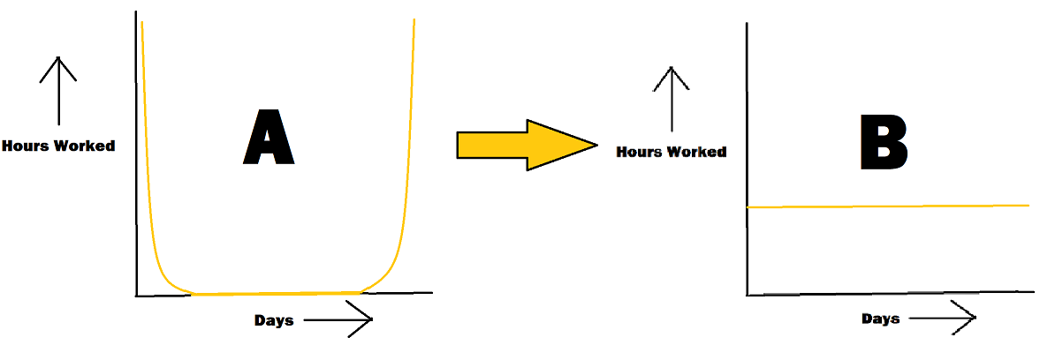

Since throughout this task I was following graph A, this turned out to be a weakness in my self-management; however I was productive enough when I was working that I was able to prevent a loss in quality of the final product, because even though I was unable to put as much time as I wished, the time I spent was distraction-free, and I was completely concentrated in my work. This was a big strength in my self-management because I was able to manage my desire to play or do something else and instead to the less interesting tasks like documentation. I was able to do this by keeping aside my phone and any other gadgets, work quietly in an unoccupied room and prevent myself from viewing pop-up advertisements on websites.

# Taking Action

## Create a product/outcome in response to the goal, global context and criteria

My final product is a graphing calculator[8] that can be run on Windows machines and can graph a variety of different functions. It plots it on a grid box that can be moved and magnified. Additionally, multiple lines can be graphed on each other and the colour scheme of the plotted graph can be changed. This graphing calculator fulfils the goal I had of creating a kind of tool as a form of personal expression of my interests and preferences that could also help educational institutes. After creation, I am affirmative that it follows the criteria for success I specified before.

## Thinking skills

Thinking is none other than the ongoing cycle of hypothesizing, analysing and reflecting on the thoughts we think of. Right from the beginning, I was met with a choice between possible projects I could have taken for the PP. After choosing to program an app, I realized that whenever a programmer is set to code, he must employ the thinking cycle to develop methods through which he may achieve his final goal, hence this project was heavily dependent on thinking skills of both forms: critical and creative. To be able to make a graphing calculator from scratch requires a lot of brainstorming and thinking to come up with a finished product. This is because most of the functionalities I wanted to add into my program were not available on the internet (which could have made my job easy). For example, when I wanted to add movement functionality into my code, I had to test a few different approaches before adding the functionality into the final product. Mind maps[9] proved to be a helpful tool as it aided me in contemplating on various possibilities while coding the application. I also faced multiple different problems[10] when coding that I had to resolve by firstly understanding the cause of the problem and then searching for a solution. Once coding the functionality of the application, the visual appeal is just as important which is why I had to spend time thinking of the colours, the dimensions of the side panel and graphing area, etc. While deciding the colours I had to refer to colour schemes and think of appropriate colour templates to solve my purpose (default, blue, etc.) which all involved thinking creatively.

## Communication and social skills

Communication skills were a quintessential part of the project as I had to frequently communicate my ideas precisely to my supervisor from time to time to report any major changes in the product. While making the product, I was taking screenshots so that I could document the creation process of the product elaborately in the future (which I have done in my process journal) which is a fine example of written communication skills that I have ameliorated through this task. Also, when I was still developing the product, I decided to present it to some math teachers (like Mr. Nitin[11]) of our school. I had given a presentation of the product and its capabilities with the intention of gaining their feedback which allowed me to work on my communication skills as well as social skills. Towards the end, I even shared the graphing calculator to my classmates and school teachers by drafting an appropriate mail. In the exhibition, the product was successfully demonstrated among teachers, students and the parent community.

# Reflecting

## Evaluation of the product against criteria.

|  |  |
| --- | --- |
| Design Specification | My product |
| It should be able to plot - functions to any degree, logarithmic functions, 6 basic trigonometric functions | It can |
| It should be able to plot various different functions together, where each different function should be drawn in a different colour | It can plot 5. Different colours, you can even plot in different colour sets altogether. |
| There should be features like movement within the graph so that the viewer can see the graph at any x value. It should be controlled with a dragging motion from the mouse cursor | It can |
| There should also be magnification implemented, so that the viewer can zoom to see the general trend of a graph etc. The zoom feature should at least be able to magnify from 0.2 to 3. It should be controlled with the scroll wheel on the mouse. | It can |
| The system must not cause too much lag. I understand that it will probably be slow to compute, but the slow speed should not interfere in the user experience. | It doesn’t interfere too much with the user experience. Although the magnification does cause some lag, it is tolerable |

## New insights in the project area.

The biggest learning (theory-wise) was about optimising my code. This is the process in which we make our code faster by restructuring it. I never had to do this before since I had never written much that was lengthy enough to cause slow processing. However, after creating this program, that requires a lot of processing power, I learnt more on how I can optimise the code. I did do some restructuring of the code, and was able to increase the speed to my best capabilities. I learnt about how one can assign separate processors in a computer to do separate tasks so that the speed can be increased. I got some understanding of threading, that I was previously unaware of. Although I was unable to implement threading properly, it was good insight that I gained through this task. Probably the most important skill I gained through this task as a coder, was to be able to read the documentations of python, Tkinter, etc. and to be able to retrieve the information I required from these large and complex manuals. I realised that a good coder is not one who remembers all syntaxes of each module perfectly (that is not possible), but one who is able to use the internet and documentation to gain the knowledge he requires with ease. This task forced me to train this skill, because I had never worked on Tkinter before. Stack Overflow was also very helpful and I found myself repeatedly going there.

The math I learnt at school allowed me to integrate knowledge of coding in python to a practical application, but I did not learn anything new about math from this project; the key take-aways were in coding.

## New insights in global context

Since my MYP personal project revolved around ‘Personal and Cultural Expressions’, with time I began to understand the relationship between my work and this global context. Everyone around us expresses their opinions and beliefs continually; so much so that it becomes ingrained in their lives, which we term as one’s culture. These opinions can be expressed in any form may it be verbal or, as in my case, non-verbal -- it is just a medium through which one can express their interests. By coding a graphing calculator, I was able to express my interests of coding to others.

## Development as an IB learner

After reflecting on the profiles I have developed in this journey, although all IB learner profiles are linked to my project in some way or the other, I have majorly polished 3 IB learner profiles:

**Thinker:** My product majorly relied on my capabilities to think for solutions to the problems I was facing when coding the application. It was the first time I was able to apply the theory I had learnt in the Udemy course in a practical application that calls for critical thinking. Additionally, the designing of UI heavily depended on creative thinking skills.

**Communicator:** Throughout the project, I have constantly been communicating my thoughts and ideas to my supervisor and have documented them down elaborately in my process journal. I have pitched my product to my teachers and also to the school on the day of the final exhibition. All these activities have provided me an opportunity to polish my communication skills (especially amidst COVID-19 when we had to remain isolated -- discouraging social interaction and communication)

**Knowledgeable:** In order to complete the graphing calculator I had learnt to use many different modules and expanded my knowledge on the python language in general. I now feel confident in creating GUI in python using Tkinter, and the practical knowledge I have learnt like how to improve speed of the application is invaluable, especially if I decide to work on another such project in the future.

# Bibliography

## Secondary Sources

### Learning Python and Tkinter

* "Python Developer Zero To Hero". *Udmey*, 2021, https://www.udemy.com/course/complete-python-developer-zero-to-mastery/learn. Accessed 6 Mar 2021.
* "Python Programming Language - Geeksforgeeks". *Geeksforgeeks*, 2021, https://www.geeksforgeeks.org/python-programming-language/.
* Dib, Firas. "Regex101: Build, Test, And Debug Regex". *Regex101*, 2021, https://regex101.com/.
* Python, Real. "Python GUI Programming With Tkinter – Real Python". *Realpython.Com*, 2021, https://realpython.com/python-gui-tkinter/.

### Other Graphing Calculators

* "Best Graphing Calculator Online (Easy-To-Use & Free)". *Meta-Calculator.Com*, 2021, https://www.meta-calculator.com/?panel-101-equations.
* "Desmos | Graphing Calculator". *Desmos*, 2021, https://www.desmos.com/calculator.
* "Graphing Calculator - Geogebra". *Geogebra.Org*, 2021, https://www.geogebra.org/graphing?lang=en.
* "Graphing Calculator - Symbolab". *Symbolab.Com*, 2021, https://www.symbolab.com/graphing-calculator.

### Stack Overflow

* 3.2, Integrating. "Integrating R With Sublime Text 3.2". *Stack Overflow*, 2021, https://stackoverflow.com/questions/55277339/integrating-r-with-sublime-text-3-2.
* "Developing Guis In Python Tkinter Vs Pyqt". *Stack Overflow*, 2021, https://stackoverflow.com/questions/1094155/developing-guis-in-python-tkinter-vs-pyqt/1747035#1747035. Accessed 6 Mar 2021.
* Infinity?, How. "How To Make Python Sympy Raise An Exception When Evaluates Or Returns Infinity?". *Stack Overflow*, 2021, https://stackoverflow.com/questions/22129932/how-to-make-python-sympy-raise-an-exception-when-evaluates-or-returns-infinity.
* Python?, How et al. "How Can I Convert A .Py To .Exe For Python?". *Stack Overflow*, 2021, https://stackoverflow.com/questions/41570359/how-can-i-convert-a-py-to-exe-for-python.
* Python?, How, and Alex Martelli. "How Can I Use Threading In Python?". *Stack Overflow*, 2021, https://stackoverflow.com/questions/2846653/how-can-i-use-threading-in-python.
* scrollbar, tkinter: et al. "Tkinter: Binding Mousewheel To Scrollbar". *Stack Overflow*, 2021, https://stackoverflow.com/questions/17355902/tkinter-binding-mousewheel-to-scrollbar.

## Primary Sources

* Recommendation by Mr. Ankur (Evidence in Appendix A)
* Interview with Mrs. Neeta (Evidence in Appendix A)

# Appendices

## Appendix A

### Mind Map to Choose Goal

The following is the mind map I used to help decide the project I would choose for the project.

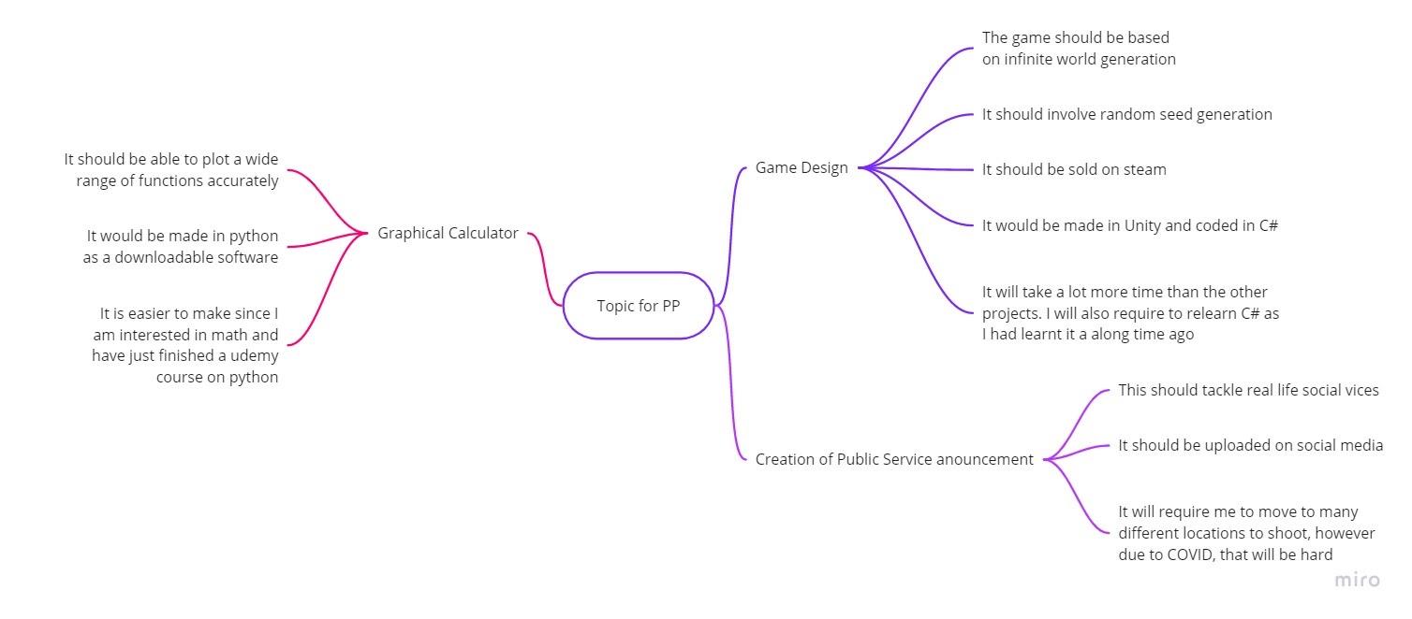

### Evidence of Course Prior Learning

Although the certificate awards Ashok Shahjade (my father) as he had paid for the course with his account, I had completed the course.

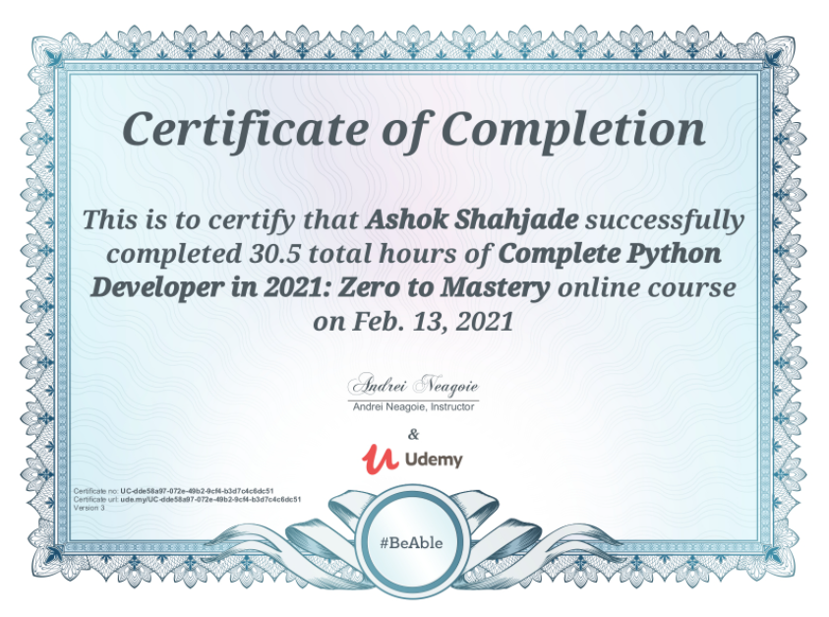

### Recommendation of Mr. Ankur

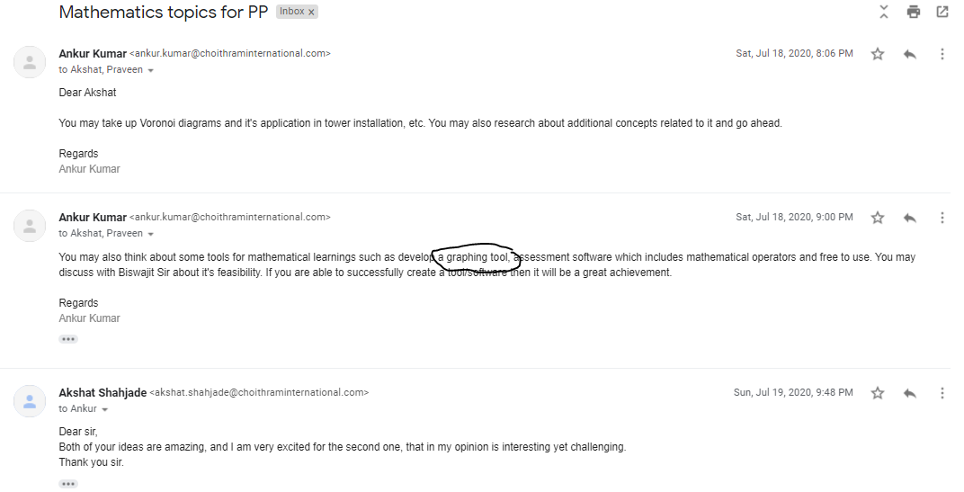Interview with Mrs. Neeta

### Contacting Professionals

#### Mail sent to Professionals

I sent this mail to various professionals, waiting for their response.

*Respected Sir,*

*My name is Akshat Shahjade (10th grader) from India. My school is an IB world school where we must complete a personal project in 10th grade that is a challenging task we undertake. For my personal project, I was able to code a fully functioning graphing calculator that is able to plot different types of graphs (normal, trigonometric, logarithmic. exponential, etc.) using the Tkinter module for GUI and the sympy module for calculations. I didn't 'cheat' by using a module like matplotlib that did everything for me and instead created this on my own. The project requires documentation and primary research which is why I had some questions to ask you and I would be elated if you would answer them.*

***Product***

*It can plot up to 5 equations at a time*

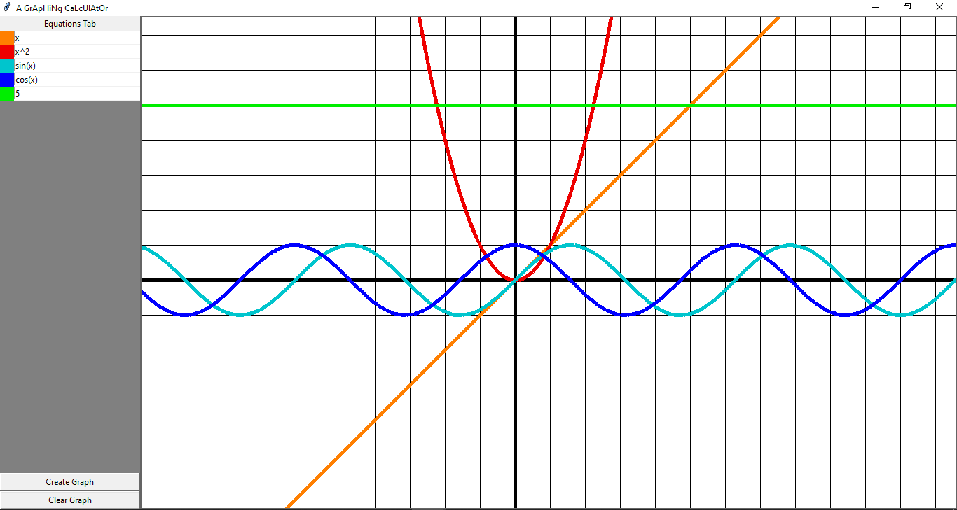

***Questions***

* *What is the general workflow of a coder (is it normal to spend more time online on sites like Stack Overflow)?*
* *Are using modules made by others online considered cheating when coding?*
* *When designing GUI for your python application, which module do you prefer to use?*
* *After making the graphing calculator, it was slow because the operations I was performing were memory intensive. How do you optimise your code; what are your top tips? (I have heard about threads and multiple processors but wasn’t able to implement that in my code due to its complexity)*
* *What are the criteria you would use to judge an application?*
* *After coding the application, what is the next step? How do you pitch it or make it available to the whole world? (I’ve already converted it into .exe format)*

*Even if you don’t reply, I thank you in anticipation for considering this email.*

*With warm regards,*

*Akshat Shahjade*

#### Reply from Ziyad Yehia

(Ziyad Yehia is the creator of a popular Udemy course called *The Python Bible™ | Everything You Need to Program in Python* with a 4.7 star rating. He is experienced in python and teaches it to thousands of students successfully.)

*Dear Respected Akshat,*

*Thank you very much for getting in touch; it is a pleasure to hear from you.*

*May I begin by stating how impressive the work that you have accomplished is.*

*I will be happy to respond to your questions.*

*1) The general workflow of a coder can fall into two branches depending upon the management style of the company they work for.*

*On the one hand, the workflow can either be "waterfall", where the coder establishes the design requirements for the project upfront, produces plans, and proceeds stage by stage, until the product is produced at the end.*

*Alternatively, the workflow can be "agile", where increasingly sophisticated versions of the whole product are developed at each stage in what are known as "sprints".*

*Agile tends to be more common these days, but the management style will depend upon what the project is trying to achieve, the customer (e.g. governments tend to favour a waterfall approach), and the workplace culture of the organisation where the coder works. Stack overflow is used when the coder is stuck, but often the coder will work in a team and ask their teammates for advice and brainstorm solutions together. Git and GitHub tend to be central tools used, as they allow collaboration and version control of software simultaneously, which helps prevent lost work and keeps everyone on the same page.*

*2) No, using other people's modules is not considered cheating, in fact it is encouraged, as long as the terms of the licenses with which that software is distributed are adhered to.*

*3) I do not do much GUI application development, but I have used Tkinter in the past, and found it okay to work with.*

*4) Optimisation is a complicated field, but I suppose you have several options.*

* *You can make your code more efficient algorithmically, so that it doesn't use as many resources (there are often multiple algorithms for a given problem, with various trade-offs).*
* *You can split the processing across multiple cores, as you have mentioned.*
* *You can program the software in a lower level language (such as C or C++).*

*5) First and foremost, I would like the application to function correctly and without bugs. Then, I would like the application to have good usability (e.g. it should be easy to use, and intuitive to use. I should "get it" when I first try to use it). Finally, I would like the interface to look nice.*

*6) This is a question of marketing. The same rules apply to software as they do to any product (i.e. clearly articulate the benefits to users, make the product available, and tell people where they can get it). For example, you can make your code open source, put it on GitHub, and then become active on forums to get attention for your project and share the link.*

*I hope my answers above are useful to you, and I wish you all the best in your studies.*

*Best wishes*

*Dr Ziyad Yehia, PhD*

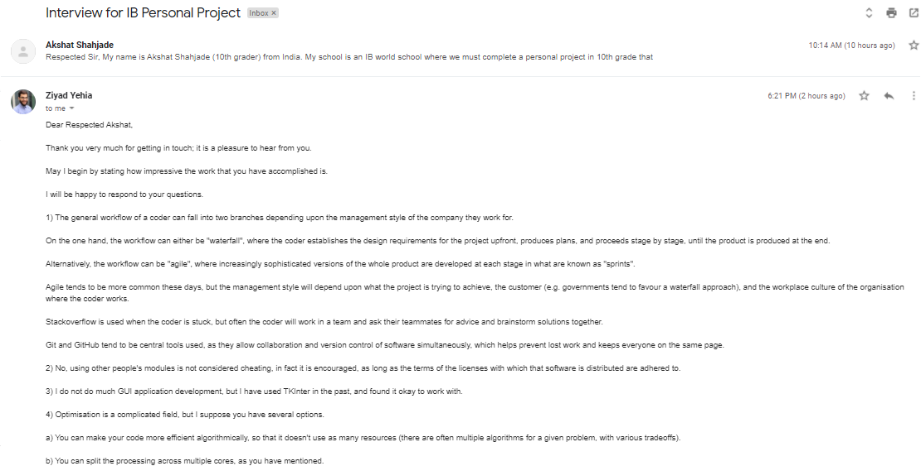

https://ssl.gstatic.com/ui/v1/icons/mail/images/cleardot.gif

## Appendix B

### Action Plan

In this plan, I attempted to only assign less work per day, so that I can do the work in a better manner with no burn out (since I usually tend to spend hours coding with a few little breaks). Although as you can see in the third column, I didn’t follow this action plan well.

|  |  |  |
| --- | --- | --- |
| When | What | Changes |
| 19/07 | I begin with the program. I start with creating a simple UI framework. I also being planning for how to make a graphing paper | I did the work of Day 1 and Day 2 on the same day |
| 20/07 | I create an ornamental graphing paper box that has no functionality yet. I also create a box where I can write simple linear equations to develop a plotting system that I can then expand to more types of functions | Did work of 21st, 22nd and 23rd today |
| 21/07 | After creating a working plotter that can plot linear equations, I will manually expand to quadratic, cubic and maybe even biquadratic (although not necessary since I plan to replace this very inflexible system) | Did the work of 26th, 28th and 29th today. Although I was unable to arrange a meeting with my math teacher to interview. |
| 22/07 | I will begin working on a more flexible method of input. I will also show this product to my math teacher who would review it | - |
| 23/07 | I will record all the progress so far with screenshots and explanation of those screenshots. | - |
| 24-25/07 | I would bring the recommendations of the teacher into the product if I agreed with them and also test a better input system. Although I do not know yet how I will create that input system. That input system should allow me to plot a function of any degree that doesn't have trigonometric ratios or other stuff like that (such as x^10 -4x^5 + 200) | - |
| 26-27/07 | I would then begin working on integrating the other types of functions like those with trigonometric ratios. I also don't know how I will be able to do this. | I used an external module named sympy |
| 28/07 | After a working system for trigonometric ratios, I don't think it will be very hard to integrate logarithmic equations. It will probably only take me one day. | - |
| 29/07 | I will work on improving the UI | - |

## Appendix C

### Product evidence

The product graphing 5 different equations in a default colour scheme (where each line is a distinct colour so that the resulting graph is clearly interpretable)



The Colour scheme is set to blue, so each line is a hue of blue. The intention of this is to produce as aesthetically pleasing graph (it uses the monotonous colour scheme)

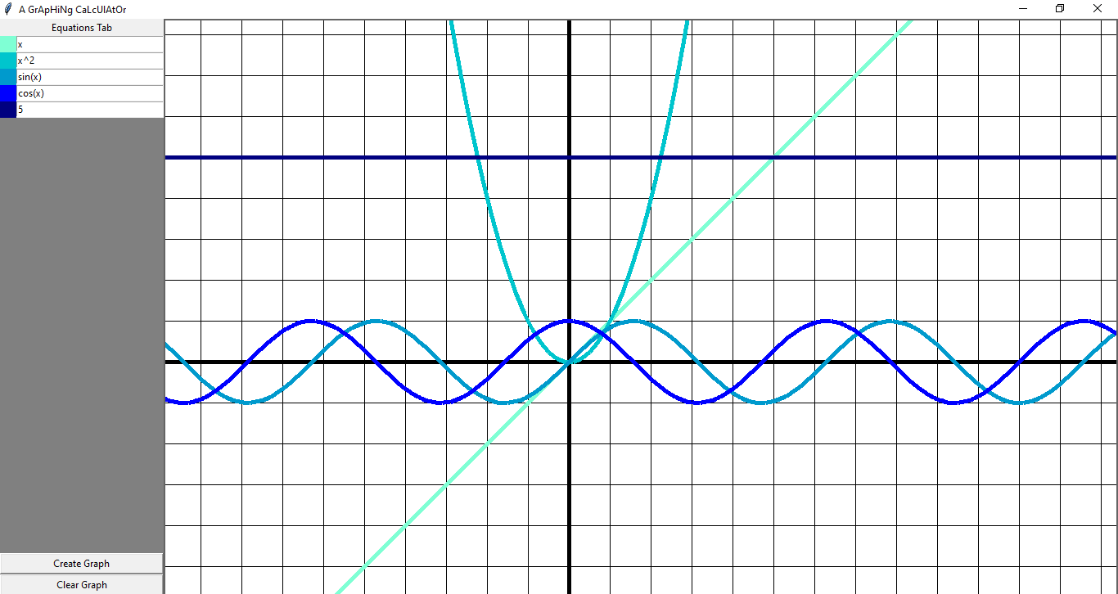

The side panel is shown in a magnified form. Clear instructions are written at the bottom to allow a new user to easily learn how to use the application. On the top, we can enter up to 5 different equations and choose the colour scheme.

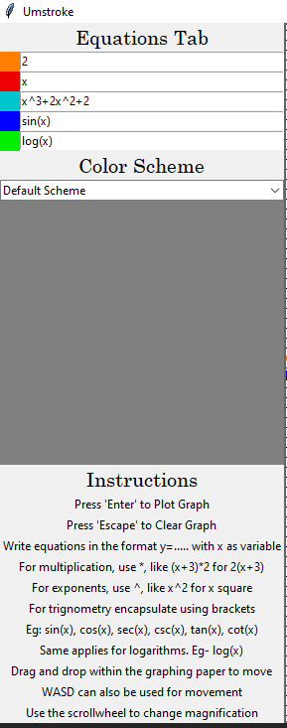

This snip shows a segment of the code that I had written in python using Sublime Text. On right edge is a mini-map which shows the whole extent of the code.

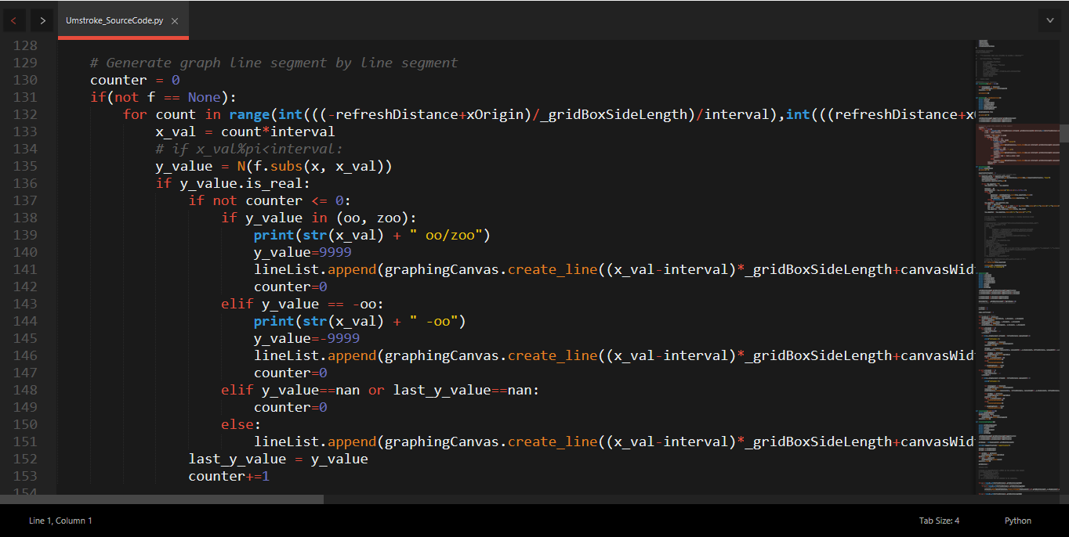

### Mind Map to aid Critical Thinking

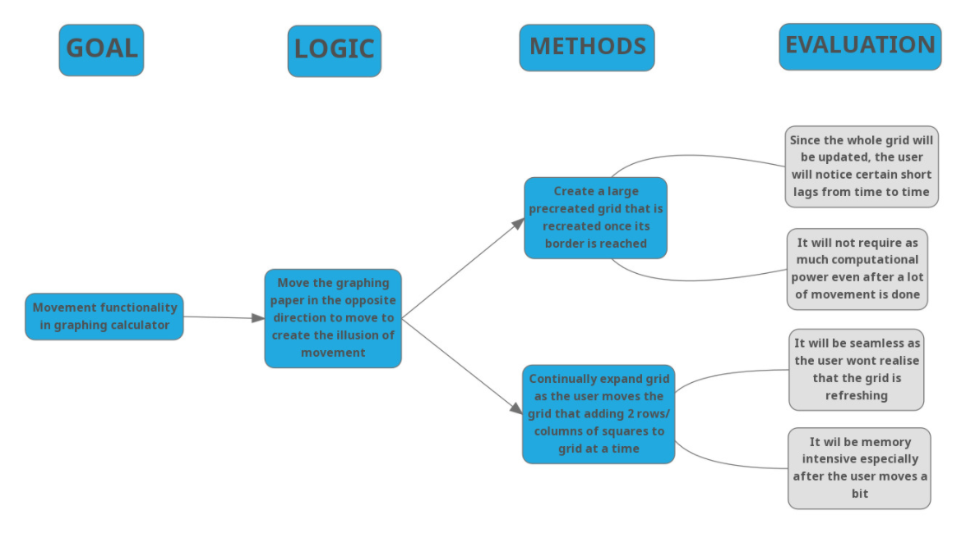

### Problems I Encountered

Here, the line that was being formed wasn’t connected properly as too many links were being created between wrong points.

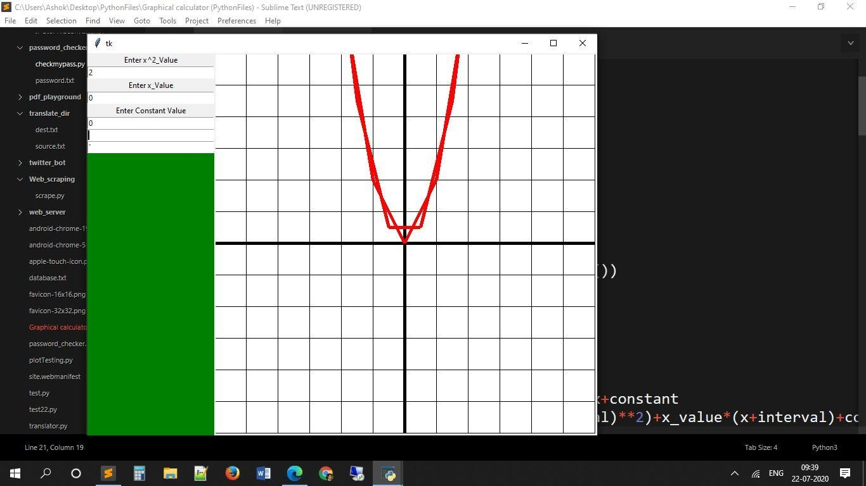

Below, The lines created aren’t joining properly and are jagged. These errors give an idea of how the program actually plots the graph (by creating many small straight lines to give the illusion of a curve)

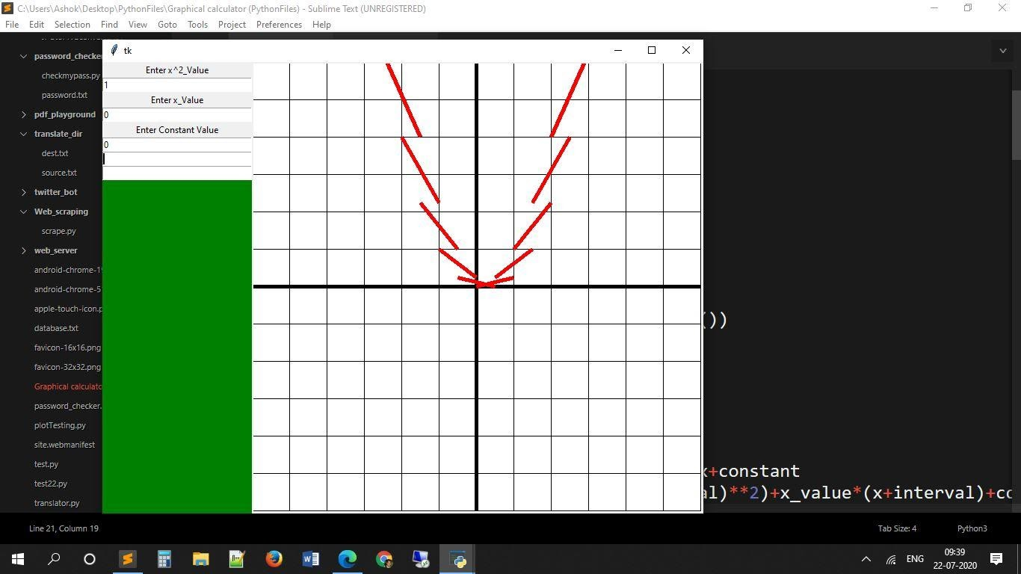

### Meeting with Mr. Nitin

Although the presentation isn’t visible in this screen shot, this is evidence of the meeting we (my PP supervisor and myself) had with Mr. Nitin who teaches mathematics in higher classes.

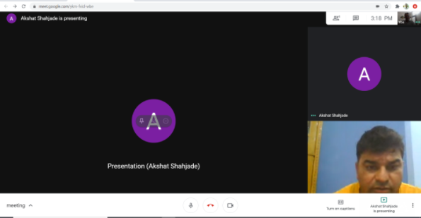

1. The mind map I used is in Appendix A : Mind Map to Choose Goal
2. Evidence of the Course is in Appendix A : Evidence of Course Prior Learning
3. Evidence of suggestion can be found in Appendix A : Recommendation of Mr. Ankur
4. Evidence of mail can be found in Appendix A : Interview with Mrs. Neeta
5. stackoverflow.com
6. Evidence of mail conversation can be found in Appendix A : Contacting Professionals
7. The Action Plan can be found in Appendix B : Action Plan
8. Product Evidence is in Appendix C : Product Evidence
9. An example of a mind map I used is in Appendix C : Mind Map to aid Critical Thinking
10. Examples of problems I faced is in Appendix C : Problems I Encountered
11. Evidence of Meeting is in Appendix C : Meeting with Mr. Nitin